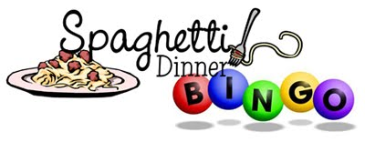
Please join us for our

Annual Spaghetti Dinner and Bingo Night

Sunday, April 30th at 5:30 PM

Dinner, Bingo, Prizes, and Tons of Fun for Everyone!

******************************************************************************

Name _________________________________________________________________________
Adults $15 #__________________
Children (3-12) $5 #____________
Children under 2 Free #_________

L’chaim Sponsor $36 includes dinner for 2 adults ____________
Shalom Sponsor $90 includes dinner for 2 adults and 2 children ____________
Mishpachah Sponsor $126 includes dinner for 6 adults or children ____________

Amount Enclosed ________________

Your check, payable to Beth El, is your reservation.
Send to: 288 N. Roscoe Blvd., Ponte Vedra Beach, FL 32082
If you have any questions, please contact Beth Brenner at 273-9100.

RSVP DEADLINE APRIL 26th

